AnkiDriod-7793

ID-45

Apk

AnkiDroid-2.14.0-x86.apk

<https://github.com/ankidroid/Anki-Android/releases?q=2.14.0&expanded=true>

Bug report description

<https://github.com/ankidroid/Anki-Android/issues/7793>

**Reproduction Steps**

1. **In Settings - AnkiDroid - Language, select a language other than English, e.g. German, French, Japanese, Chinese simplified.**

**Then, in the language,**

1. **Select Settings - Gestures - Enable gestures.**
2. **Tap Swipe up.**
3. **Tap Bury note in the menu.**
   * **Strictly speaking, to make sure, tap the item whose string should correspond to Bury note.**
4. **Swipe up on the study screen.**

**Expected Result**

* **The next card is displayed.**
* **Then, if you select English in Language, and re-open the Swipe up action menu, you see Bury note selected, of course.**

**Actual Result**

* **The learning is aborted, and the home screen (the Decks screen) is displayed.**
* **Then, if you select English in Language, and re-open the Swipe up action menu, you see Abort learning selected.**

**[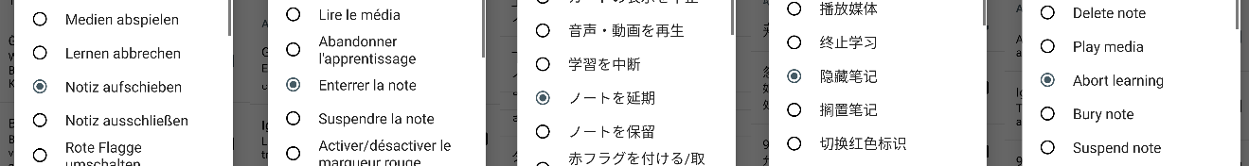](https://user-images.githubusercontent.com/10436072/100534256-2f768100-3250-11eb-904e-bb05c41a3cb3.png)**

**Debug info**

* **Ver.2.14.0**
* **The upper 10 items in the menu (the items above the blue line in the following image) work properly.**

**[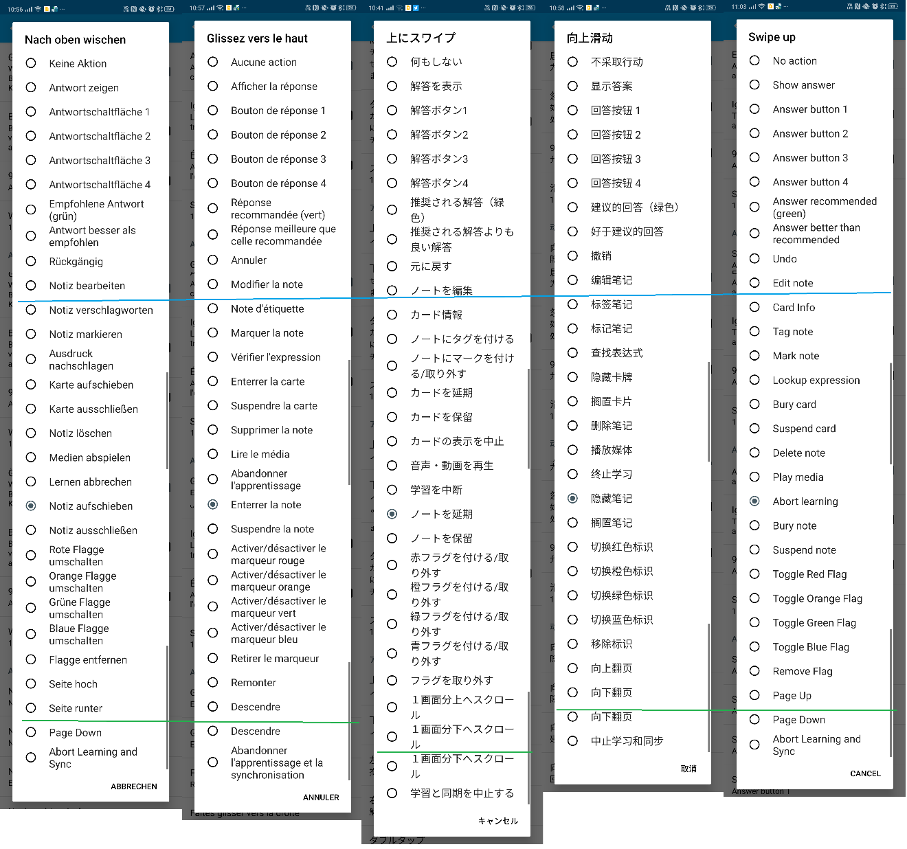](https://user-images.githubusercontent.com/10436072/100534168-36e95a80-324f-11eb-9bb2-c99a12faba78.png)**

* **In languages other than English and Japanese, the string which should correspond to Card info doesn't exist.**

**(In Japanese, it didn't either, but I added it on November 8. The Japanese string which should correspond to Lookup expression has gone missing instead.)**

* **Instead of the string which should correspond to Card info, the string which should do to Tag note actually correspond to Card info. In other words, the translated string for Tag note has slid up to the position of Card info.**
* **This "sliding up by one step" continues until the item whose string should correspond to Page Down, i.e. until the third item from the bottom (the item on the green line in the image).**
* **The second item from the bottom, whose string also correspond to Page Down, works properly, or the item hasn't been translated (e.g. in German).**
* **This discordance has originally occurred on Crowdin for some reason.**

Screen shots sequence

1. Change system language to Japanese

1. Set gestures ‘swipe up’ to ‘bury note’, in Japanese

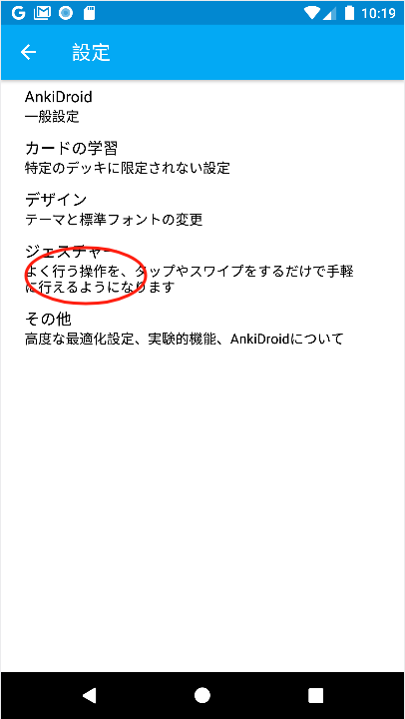

1. View cards and swipe up

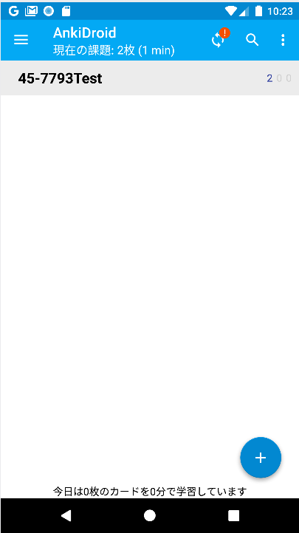

1. Change language to English then see gestures

